Sprint 1 - Endurance Design Document

October 26, 2022

**Table of Contents**

**1.** **Executive Summary 3**

1.1 Project Overview 3

1.2 Purpose and Scope of this Specification 3

**2.** **Product/Service Description 3**

2.1 Product Context 3

2.2 User Characteristics 3

2.3 Assumptions 3

2.4 Constraints 3

2.5 Dependencies 4

**3.** **Requirements 4**

3.1 Functional Requirements 5

3.2 Security 5

*3.2.1* *Protection 5*

*3.2.2* *Authorization and Authentication 6*

3.3 Portability 6

**4.** **Requirements Confirmation/Stakeholder sign-off 6**

**5.** **System Design 6**

5.1 Algorithm 6

5.2 System Flow 6

5.3 Software 6

5.4 Hardware 6

5.5 Test Plan 7

5.6 Task List/Gantt Chart 7

5.7 Staffing Plan 7

# Executive Summary

## Project Overview

The first project, sprint 1, endurance design. Where the robot (Sphero) must successfully travel around the periphery of HH208 (circumnavigate). A clear path will be provided from each outside wall. Robot will start from the yellow square with blue tape. Robot should start with a green light and speak ‘ready set go’ and stop with a red light and say ‘I’m done and I need water’. Robot must travel to each of the yellow floor tiles and turn right at the center of each tile. Robot must return to its starting location. Robot should not collide with any objects as it goes around the room. Points deducted if the robot does not light and speak at start and finish, if it collides with anything, or if it does not finish in the square where it started. (You may scale down the course for this sprint if space is an issue).

## Purpose and Scope of this Specification

The goal is for the Sphero robot to follow its path correctly

In scope

This document addresses the processes and requirements to carry out the endurance project:

* Modifications in the process so that the robot complies with its trajectory.

Out of Scope

* Having the robot follow the blue tape exactly, rather than just being within a inch or two from the tape while traveling around the course.

# Product/Service Description

The factors that can affect the product and its requirements are that if for example there is an object in the path of the robot, such as a table, a wall, a chair, a person, etc., because it cannot advance in the desired direction. In addition, if the floor is sloping, it deflects the robot a bit. Also, if the floor is smooth, it will make it slide a little more, but in this case the result will be very similar to what is desired.

## Product Context

The product relates to other products, this means that the robot Sphero is related to other robots, because Sphero is a robot that is controlled remotely. It is self-contained because it contains in itself everything necessary to work. It interfaces with a variety of related systems.

## User Characteristics

Professor Gil Eckert from Monmouth University, master from Kean University and bachelor of science from Stockton State College. He has a lot of knowledge in computer science and software engineering, with a certified network engineer. He did research in simulation, data analysis and manipulation, algorithmic development, and quality control.

## Assumptions

Although we are not experts in programming Sphero, with what Professor Gil taught us, as a group we have the necessary skills to do the programming. We feel we need to know a little more about this programming. In addition, it is important to have room HH208 available to be sure that the robot makes its way as it should.

## Constraints

Constrain the design options, including

* Connecting to another robot or executing another programming affects the route that you want to give the robot.
* access, management and security
* system resource constraints: limits on disk space, obstacles in the way of the robot)

## Dependencies

This new product required programming. For the programming, it is required to have the robot Sphero and the space.

# Requirements

## Functional Requirements

| **Req#** | **Requirement** | **Comments** | **Priority** | **Date Rvwd** | **SME Reviewed** |
| --- | --- | --- | --- | --- | --- |
| ENDUR_01 | Start with the green light | Points will be deducted | 1 | 11/2/22 | Approved |
| ENDUR_02 | Robot says “Ready set go” | Points will be deducted | 1 | 11/2/22 | Approved |
| ENDUR_03 | Robot must travel around course | Points will be deducted | 1 | 11/2/22 | Approved |
| ENDUR_04 | Robot must stop at initial starting point | Points will be deducted | 1 | 11/2/22 | Approved |
| ENDUR_05 | End with the red light | Points will be deducted | 1 | 11/2/22 | Approved |
| ENDUR_06 | Say “I’m done and I need water” | Points will be deducted | 1 | 11/2/22 | Approved |
|  |  |  |  |  |  |
|  |  |  |  |  |  |
|  |  |  |  |  |  |

## Security

Take care of your privacy, do not tell other people your login information to Sphero or github.Also, take care of your robot, keep it away from dangerous environments.

### Protection

You are the one who controls your app and your programming. After downloading the Sphero app, you can log in in two ways, school and home. When you enter the school part, three different options appear. The first is student, where it asks you for a code to join your class and share your program with them. The second is the teachers, where it allows you to create a class and manage it, this way the professor will be able to know the process that the students have. The third is to skip the sign in part and start programming immediately, these users have the possibility to sign in whenever they want. On the other hand, there is a home, where you can enter through your email or also sign in with apple.

### Authorization and Authentication

Authorization and Authentication factors. Consider using standard tools such as PubCookie.

## Portability

Portability is the ability of software to be transferred from one machine or system to another. In this case, after programming from the cell phone or the computer, we need to pass the information to the sphero robot so that this can work. For example,

* Use of a proven portable language;
* Use of a particular operating system. Sphero and gitHub;
* The need for environment-independence - the product must operate the same regardless of operating systems, networks, development or production environments.

# Requirements Confirmation/Stakeholder sign-off

Documentation of the approval or confirmation of the requirements here. For example:

| **Meeting Date** | **Attendees (name and role)** | **Comments** |
| --- | --- | --- |
| 11/02/22 | Michael, Sophia, Mark | confirmed all requirements |
| 11/03/22 | Michael, Sophia | confirmed all requirements |

# System Design

This section will provide all details concerning the technical design, staffing, coding, and testing the system.

## Algorithm

* Set robot’s light to green
* Robot says “Ready set go”
* Set robot to travel forward until it reaches the first checkpoint
* Set robot to stop at first checkpoint
* Robot will turn right 90 degrees and move on to the next checkpoint
* Repeat steps 3-5 until robot is back at its initial starting point
* Set robot to stop at starting point
* Set the robot’s light to red
* Robot says “I’m done and I need water”

## System Flow

Flowchart

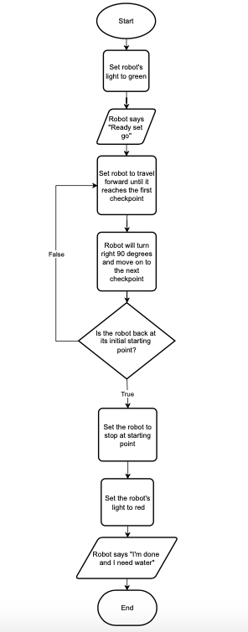

## Software

The software used to develop and deploy this application is the block code on the Sphero app or website.

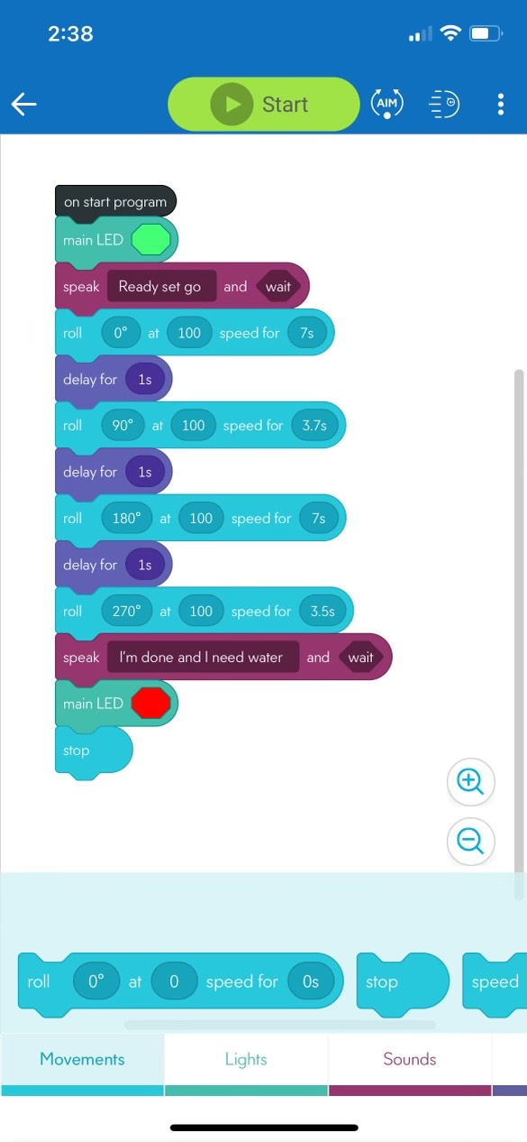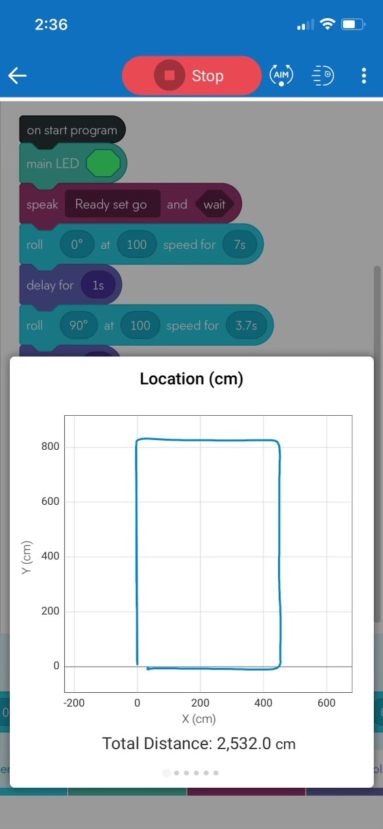

## Hardware

The hardware platforms that were used to develop, test and demonstrate this application were macOS, Microsoft Windows, and IOS.

## Test Plan

| **Reason for Test Case** | **Test Date** | **Expected Output** | **Observed Output** | **Staff Name** | **Pass/Fail** |
| --- | --- | --- | --- | --- | --- |
| Try to stop at first checkpoint | 11/2/22 | Stop at first corner | Robot went too far past corner | Mark | Fail |
| Try to stop at first checkpoint | 11/2/22 | Stop at first corner | Stopped too short | Mark | Fail |
| Turn at first corner | 11/2/22 | Turn at first corner | Made it to second corner | Mark | Pass |
| Turn at third corner | 11/2/22 | Not hit chairs after second turn | Hit chairs after second turn | Mark | Fail |
| To turn at second corner on time | 11/2/22 | Make it to third turn | Turned a little early but made it to the end of course. | Mark | Pass |
| To film video | 11/2/22 | Complete the course | Robot made it to end of the course | Mark | Pass |
|  |  |  |  |  |  |
|  |  |  |  |  |  |
|  |  |  |  |  |  |
|  |  |  |  |  |  |
|  |  |  |  |  |  |

## Task List/Gantt Chart

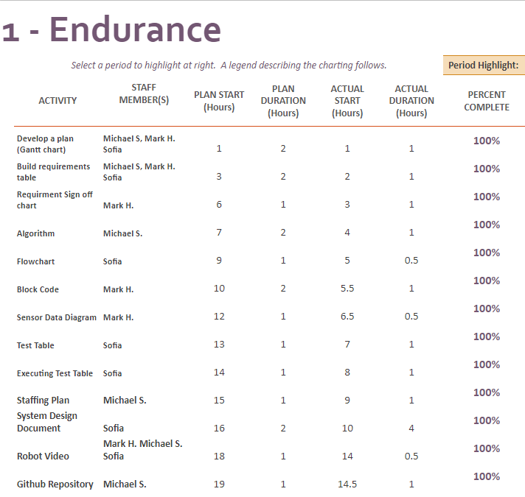

## Staffing Plan

| Name | Role | Responsibility |
| --- | --- | --- |
| Sophia | SDD creator/editor | Create and edit the System Design Document |
| Mark | Programmer | Create the block cod and test it |
| Michael | Github Owner | Contro the Github repository |